London Universities Purchasing Consortium

Senior Category Manager
Job Specification

October 2021

JOB SPECIFICATION

LONDON UNIVERSITIES PURCHASING CONSORTIUM

Job Title: SENIOR CATEGORY MANAGER

Job Summary

The initiation and development of supply agreements to achieve best value for money in non-pay expenditure. The application of management, administration and procurement techniques to achieve LUPC’s business objectives with professional competence. They will act as an ambassador for the Consortium ensuring that customer needs are met and encouraging new Membership and the marketing of their agreements to Members.

All tasks require a pro-active, high quality approach and personal attributes to ensure close working with Member Institutions, ensuring the continuous improvement of best value procurement for the LUPC and its Members.

Job Content

1. LUPC Commodity/Service Groups

a) To lead or take part in groups and working parties with other HE or public sector consortia as required.

b) To initiate, develop and execute sourcing strategies and contracting plans for goods and services agreements.

c) To design and/or assist in the development of product/service specifications.

d) To produce and execute tenders for the relevant spend categories, including those through the EU procurement process. This will include negotiating as appropriate.

e) To design each procurement process such that it delivers LUPC’s Responsible Procurement Policy and Strategy and addresses the specific risks inherent in that category, to add to LUPC’s significant reputation in this area.

f) To develop selection and award criteria as part of the tender process. This will include risk analysis based e.g. on market intelligence and the formulation of recommendations.

g) To continually manage and improve established agreements with suppliers.

h) To keep up to date with legislation and case law pertaining to the areas of responsibility.

- To aim to become technically proficient in the relevant spend categories in order to complete the responsibilities to the best advantage of the Consortium and be able to share that knowledge internally.
j) To network with estates and FM professionals nationally through HE purchasing consortia and other sector body groups, including for example AUDE. Attending events and contributing to discussion appropriately.

2. Market Intelligence

a) To assess which supplier’s offer the desired products and services and their performance in the market place and to use this intelligence to form the basis of tender arrangements. Possible new markets for Members’ required products and services are also to be investigated and assessed.

b) To keep up to date on current affairs that may have an impact on the markets.

c) To understand and anticipate Member Institutions’ current and future needs. To maintain regular contact with Members, identify and anticipate needs at the earliest opportunity, ensuring the earliest match between their requirements and the supplier market place.

3. Supplier Relationship Management

a) To manage and develop best value relationships between LUPC, suppliers and Member Institutions through regular liaison meeting or other methods as appropriate.

b) To work with Member Institutions and suppliers to obtain the optimum use of agreements, including organising supplier exhibitions, promoting agreements, ensuring that suppliers have the right contacts and meet the changing needs of Member Institutions.

c) To conduct supplier performance assessments and vendor rating.

4. Consultancy for Members or other clients

To use the appropriate skills, experience and information to advise Member Institutions or other clients during or prior to their own procurement exercises, typically for one-off, high-value transactions.

5. Legislation

a) To keep up to date with the existing and proposed public procurement legislation that may affect the Consortium and/or its Membership.

b) To ensure compliance with existing and proposed public procurement legislation.

c) To act as a source of knowledge and expertise on the methods and implications of applying such legislation from both the Consortium’s and suppliers’ point of view and to transmit this information to Members, e.g. through training programmes.

This requires a constantly updated knowledge of contract law as applicable to procurement.

6. Training

a) To assist the identification, development, and co-ordination of training to meet Members’ needs.

b) To assist in the organisation and availability of training courses, seminars and workshops as required.

c) To promulgate procurement best practice.

7. Promoting the Use of Supply Agreements

To liaise with the Deputy Director in the development and execution of the LUPC corporate strategy to raise LUPC’s profile in the HE and wider public sectors and promote the use of agreements.

8. Any other task as required by the Director of LUPC.

Job Requirements

See Appendix: Person Specification

________________________________________________________________

Chain of Responsibility

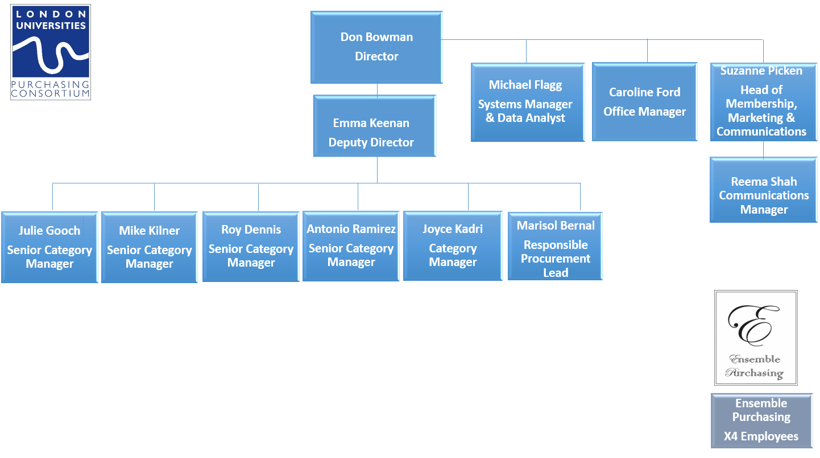

Name:

Signed:

Date:

Emma Keenan, Deputy Director, October 2021

APPENDIX: PERSON SPECIFICATION
Applicants should note that they will need to demonstrate that they possess the qualities set out in the person specification with reference to the specific post. During the appointment process and in your cover letter with your application, you should specifically outline how your experience, professional background (including qualifications and/or membership of any relevant professional body) and current knowledge fits the requirements for the post.

ATTRIBUTES | ESSENTIAL | DESIRABLE | HOW IDENTIFIED
EXPERIENCE | Proven experience in professional procurement and contract management, including:  - Ability to manage large (preferably collaborative) procurement projects from feasibility to implementation, that bring tangible benefits  - Ability to develop complex specifications and tender evaluation mechanisms  - Ability to develop effective relationships and joint working both internally and with external bodies/suppliers. | - Experience of working in a collaborative procurement environment with a range of stakeholders.  - Knowledge of the Estates spend category and markets. | Curriculum Vitae and selection process.

ATTRIBUTES | ESSENTIAL | DESIRABLE | HOW IDENTIFIED
QUALIFICATIONS | - Educated to ‘A’ Level or equivalent, plus Membership of the Chartered Institute of Purchasing and Supply (MCIPS) or working towards this. | - A professional, academic or management qualification at degree level relevant to the skills and abilities required for the job.  (Candidates must demonstrate relevance to the specific job) | Curriculum Vitae plus certificate / document checks.
TRAINING |  | - Able to demonstrate recent and continuing professional and personal self-development including leadership skills, management training and equal opportunities. | Curriculum Vitae and selection process.
KNOWLEDGE | - Demonstrable knowledge of the statutory, regulatory, strategic and key operational issues relevant to the post, specifically, knowledge of contract law and legislation as it applies to procurement.  - Knowledge of the principles of best value and performance management and the impact on the procurement process. | - Understanding of Higher Education issues/agenda, equality, diversity, socio-economic and environmental sustainability.  - The strategic role of information technology and its applications.  - Knowledge of e-procurement.  - Awareness of ethical issues. | Curriculum Vitae and selection process.

ATTRIBUTES | ESSENTIAL | DESIRABLE | HOW IDENTIFIED
CIRCUMSTANCES – PERSONAL | - Must be legally entitled to work in the UK.  - Must be prepared to work unsocial hours if required. |  | Curriculum Vitae and selection process.
DISPOSITION – ADJUSTMENT / ATTITUDE | - Must be able to command the confidence of all key stakeholders and commodity group representatives.  - Able to demonstrate sound judgement and commercial awareness and a high degree of personal and professional probity and integrity.  - Capacity to work under pressure, meet deadlines, satisfy objectives and organisational priorities. |  | Assessment during selection process.
PRACTICAL & INTELLECTUAL SKILLS | - A persuasive communicator with an ability to present ideas on a range of issues and excellent in both written and oral forms of communication.  - Able to demonstrate a high level of analysis, problem solving and negotiating skills.  - Extremely good organisational skills, with the ability to prioritise work and reach decisions calmly and quickly under pressure.  - Experience of MS Office packages. | - Ability to develop spreadsheets for data monitoring and analysis. | Curriculum Vitae  Assessment during selection process.
ATTRIBUTES | ESSENTIAL | DESIRABLE | HOW IDENTIFIED
PHYSICAL / SENSORY | - Must be able to perform all duties and tasks with reasonable adjustment, where appropriate. |  | Discussion at interview.

