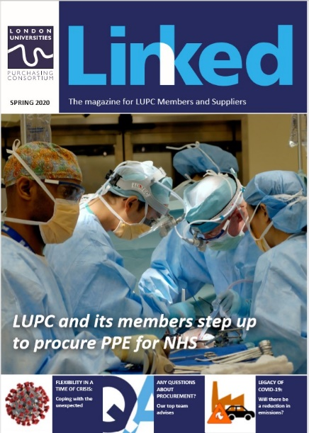
Advertising in LUPC’s Linked magazine

To cover the costs of producing a quarterly edition of LUPC’s Linked magazine, we offer LUPC approved suppliers the opportunity to advertise.

Benefits

- Our circulation includes more than 300 individual buyers at more than 80 member institutions, plus all of LUPC’s suppliers.
- The magazine reaches a section of contract users that do not regularly access the web.
- The magazine is also available to anyone who accesses the LUPC website, including back issues.
- Your support demonstrates to customers your commitment to LUPC agreements.

Advertisement Rates

- £175 +VAT for quarter page
- £300 +VAT for half page
- £500 + VAT for full page
- 10% discount available for booking 4 consecutive spaces in advance

Invoices are sent once the issue with the advertisement is published. Payment is due by 30 days past invoice date.

Please note, if you are no longer an approved supplier to LUPC Members at the date of publication, we cannot publish your advert and we will refund your payment.

Guidelines

- Advertisement and editorial submissions are granted strictly on a first come, first serve basis.
- Deadlines must be strictly adhered to.
- Artwork guidelines must be followed.
- Suppliers may not specifically promote goods and services that are outside the scope of your agreement with LUPC – promoting products covered by the agreement and/or a general company advert (making reference to the agreement) is fine.
- All adverts must include:

- Supplier contact details (a website, email etc)
- Reference should be made to the agreement and, where relevant, agreement logo
- The standard term for approved suppliers is ‘LUPC framework supplier’, not ‘Preferred
supplier’ or ‘Number 1 Supplier’.

Artwork specification

- Supply artwork as a high resolution, print ready pdf to Suzanne Picken.  - Advert bleed to be 3mm | - Images to be high res and colour, min. 300dpi  - Please ensure fonts are embedded in adverts when the PDF is created
Copy Area :

- Full page 210mm (horizontal) x 297mm (vertical)
- Horizontal Half page 192mm (horizontal) x 144mm (vertical)
- Quarter page 94.5mm (horizontal) x 144mm (vertical)

Contacts and booking

To book your advert, you must sign the authorisation form on page 3 and return this to Suzanne Picken.

For queries about bookings, please contact Suzanne Picken, 020 7307 2776.

Editorial Submissions

We also welcome articles from suppliers about current issues/updates in your commodity markets, case studies, best practice, sustainability etc. There is no charge for placing these articles, but they must focus on the ‘big issues’, rather than being an overt ‘sell’ for a particular supplier. For more information contact Suzanne Picken, 020 7307 2776.

Schedule

Summer 2020 (published July)
Artwork deadline: Friday 26th June 2020

Autumn 2020 (published October)
Artwork deadline: Friday 25th September 2020

Winter 2020/21 (published January)
Artwork deadline: Wednesday 16th December 2020

Spring 2021 (published April)
Artwork deadline: Friday 26th March 2021

Linked Advertising Authorisation Form

Company Name:

Name:

Email:

Tel:

Purchase Order Number (if applicable):

Invoice Address:

Which issue? (Dates of publication in brackets)

Summer 2020 (July) Autumn 2020 (October)

Winter 20/21 (Jan) Spring 2021 (April)

Size of advert:

Quarter page

£175 +VAT

Half page

£300 +VAT

Full page

£500 + VAT

- 10% discount available for booking 4 consecutive spaces in advance

Please state if half page advert will be horizontal or vertical in orientation:____________________________

Signature and date

Please note: This booking form commits you to paying for the agreed advertising after publication. Adverts cancelled 21 days before the advert artwork deadline will be charged 100% of the agreed fee.
Email completed form to: Suzanne Picken

