LUPC Marketing Opportunities Booking Form
LUPC offers opportunities for approved consortia suppliers to advertise their goods and services covered under the scope of their framework agreement with us. These are: Advertising on two of the most high-traffic pages on the LUPC website, placing an advert or submitting an article for our quarterly digital magazine, Linked. Additionally, we offer competitive marketing offers and bundles exclusively to our framework suppliers. The specification for each advert, as well as a breakdown of costs and offers are listed below. To book, fill in the form below making sure to tick your preferences and email to Giorgia Varriale who will be able to confirm availability.
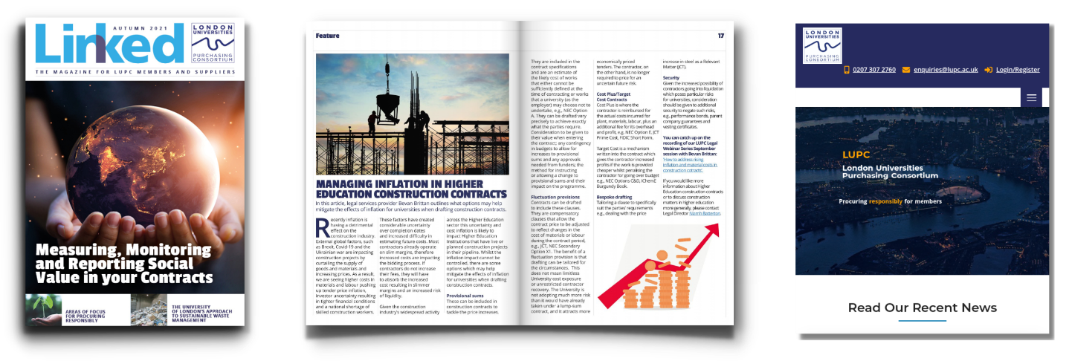

Advertising on the LUPC Website
💳 £495+VAT per calendar month
10% discount available for booking 4 consecutive spaces in advance. Bundles available, details below.
🔍Website Advert Specification
- 1110px (width) x 170px. (height) (for website)
- 290px (width) x 400px (height) (for mobile)
- High quality images. Accepted file format: JPEG, PNG or GIF (animated or static).
- Website page/url or email address of where the ad should point to.
You will be featured in two of the most high traffic pages on our website, the homepage and the framework agreement page.

Website Advertising Bundles
No. of months booked | Total Cost | Discount off full price | Saving
1 | £495+VAT | N/A | N/A
2 | £940+VAT | 5% | £50+VAT
3 | £1335+VAT | 10% | £150+VAT
4 | £1,680+VAT | 15% | £300+VAT

Advertising In Linked Magazine
Our quarterly digital magazine, Linked, is emailed to 500+ members and all our suppliers. It is also shared online on our website and social media. Full, half and quarter page adverts are available for purchase, rates and specs are detailed below.
💳 Linked Magazine Advertisement Rates:
  - £175 +VAT for quarter page
  - £300 +VAT for half page
  - £500 + VAT for full page
10% discount available for booking 4 consecutive spaces in advance. Bundles available, details below.
🔍Artwork Guidelines & Specifications
- Supply artwork as a high resolution pdf to Giorgia Varriale
- Images to be high res and colour, min. 300dpi
- Advert bleed to be 3mm
- Please ensure fonts are embedded in adverts when the PDF is created.
- All adverts must include:
- Supplier contact details (a hyperlink to your website or an email address)
- Reference must be made to the framework agreement and reference number in your advert
Please note: The standard term for approved suppliers is ‘LUPC framework supplier’, not ‘Preferred supplier’ or ‘Number 1 Supplier’.
Copy Area :

- Full page 210mm (horizontal) x 297mm (vertical)
- Half page 210mm (horizontal) x 148mm (vertical)
- Quarter page 105mm (horizontal) x 148mm (vertical)

Linked Magazine + Website Advertising Bundles
No. of Linked Magazine adverts | Page Size | Cost | With 1 month discounted web ad (usually £495+VAT) | Total Cost
1 | Quarter | £175+VAT | £395+VAT (20% discount) | £570+VAT
4 consecutive editions | Quarter | £630+VAT (10% discount) | £345+VAT (30% discount) | £975+VAT
1 | Half | £300+VAT | £395+VAT (20% discount) | £695+VAT
4 consecutive editions | Half | £1080+VAT (10% discount) | £345+VAT (30% discount) | £1,425+VAT
1 | Full | £500+VAT | £395+VAT (20% discount) | £895+VAT
4 consecutive editions | Full | £1,800+VAT (10% discount) | £345+VAT (30% discount) | £2,145+VAT

Submitting and article for Linked Magazine

We also welcome articles from suppliers about current issues/updates in your commodity markets, case studies, best practice, sustainability etc. There is no charge for placing these articles, but they must focus on the ‘big issues’, rather than being an overt ‘sell’ for a particular supplier.

Please be aware, our free supplier editorials are not advertorials – each article from a supplier must focus on the ‘bigger picture’ i.e. – case studies (especially including LUPC members), new legislation, best practice, hints and tips from your industry etc. It should not be used to promote off-contract goods/services and it shouldn’t be an overt sell for your company or its specific products (for this, you’ll need to buy advertising from us). To be fair to other suppliers we will edit this if it veers off the wrong path – if unsure, please have a read through some of our past issues, which include supplier- written editorials and hit the right tone. Of course, we’ll by- line this article to you and include your logo and contact details, so there are definitely benefits!

For more information contact Giorgia Varriale, in the first instance with a short overview of your topic, so we can confirm space is available in a future issue and that this doesn’t duplicate another article. On approval, all articles would need to be 650 words.

Linked Magazine Schedule

Spring 2024 (published end of April)
Artwork deadline: Friday 22 March 2024

Summer 2024 (published end of July)
Artwork deadline: Friday 21 June 2024
Autumn 2024 (published end of October)
Artwork deadline: Friday 25 September 2024

Winter 2025 (published end of January)
Artwork deadline: Friday 6 December 2024

Ts & Cs:
- Advertisement and editorial submissions are granted strictly on a first come, first serve basis.
- Deadlines must be strictly adhered to.
- Artwork guidelines must be followed.
- Suppliers may not specifically promote goods and services that are outside the scope of your agreement with LUPC – promoting products covered by the agreement and/or a general company advert (making reference to the agreement) is fine.
- Please include a document with the hyperlinks you want featured on your artwork and limit these to a max of 4 links per artwork.
- Web Advertising: The advertisement period begins when you have selected the month to start advertising. For example, if you request to advertise in January, your banner ad will run from January 1st –31st. Subject to availability, we may be able to place your advert mid-month at a pro-rata price.
- Payment Terms: This booking form commits you to paying for the specified advertising within 30 days of the invoice date. A refund will only be provided if you give 21 days or more notice of cancellation to LUPC before the advert artwork deadline.

Advertising Booking Form

Please indicate where you would like to place your advert:
Linked Magazine Website advertising
Company Name:

Name:
Email:

Tel:

Purchase Order Number (if applicable):
Invoice Address:

Linked Magazine advertising

Which Linked Magazine issue? (Dates of publication in brackets)

Summer (end of July) Winter (end of January)

Autumn (end of October) Spring (end of April)

Advert size & pricing for Linked Magazine:

Quarter page Half page Full page
£175 +VAT £300 + VAT £500 + VAT

Please state if half page advert will be horizontal or vertical in orientation:
2. Web Advertising
When would you like to advertise on the LUPC website?
Please put an X next on the desired month below. £495 + VAT per month.
A 10% discount is available for consecutive bookings of four months and over.

January |  | July
February |  | August
March |  | September
April |  | October
May |  | November
June |  | December

- Bundles

Website Advertising Bundles

No. of months booked | Total Cost | Discount off full price | Saving | Selected Option (please mark with an x) | Which month?
1 | £495+VAT | N/A | N/A
2 | £940+VAT | 5% | £50+VAT
3 | £1335+VAT | 10% | £150+VAT
4 | £1,680+VAT | 15% | £300+VAT

Linked Magazine + Website Advertising Bundles

No. of Linked Magazine adverts | Page Size | Cost | With 1 month discounted web ad (usually £495+VAT) | Total Cost | Selected Option (please mark with an x) | Detail edition (Spring, Summer, Autumn, Winter)
1 | Quarter | £175+VAT | £395+VAT (20% discount) | £570+VAT
4 consecutive editions | Quarter | £630+VAT (10% discount) | £345+VAT (30% discount) | £975+VAT
1 | Half | £300+VAT | £395+VAT (20% discount) | £695+VAT
4 consecutive editions | Half | £1080+VAT (10% discount) | £345+VAT (30% discount) | £1,425+VAT
1 | Full | £500+VAT | £395+VAT (20% discount) | £895+VAT
4 consecutive editions | Full | £1,800+VAT (10% discount) | £345+VAT (30% discount) | £2,145+VAT

Agreed to Terms and conditions
Email completed form to: Giorgia Varriale

