This template largely follows the layout of CRP in PPN 06/21, with the following additions:
- Scope 3 categories to enable focussed emissions reductions in emissions hotspots.
- A commitment to providing product/service carbon emissions data.
- 5-year carbon reduction targets up to 2050, including offsets
- Offsetting plan detail

Carbon Reduction Plan Template

Supplier name: ………………………………………………………………….
Publication date: ………………………….........................................

Commitment to achieving Net Zero
[Supplier name] is committed to achieving Net Zero emissions by 20XX.
Our Net Zero Target [was/will be] validated externally by XX [on/by] date.

Commitment to Provision of Reliable Emissions Data
We are committed to providing emissions measurement for Scopes 1, 2 and 3 according to the GHG Reporting Protocol corporate standard and using the appropriate government emission conversion factors& for GHG reporting.
We are committed to providing emissions data based on actual carbon emission factors per unit of product or service provided [by xxxx].

Baseline Emissions Footprint
Baseline emissions are a record of the greenhouse gases that have been produced in the past and were produced prior to the introduction of any strategies to reduce emissions. Baseline emissions are the reference point against which emissions reduction can be measured.
[Instructions to Suppliers: Please provide details of your organisation’s baseline emissions below. If your organisation has not previously assessed or reported emissions, please detail this below and use your first reporting period as your Baseline.]

Baseline Year: 20XX
Additional Details relating to the Baseline Emissions calculations.
[Instructions to Suppliers: Add commentary regarding your Baseline Emissions as required: e.g. historic baseline which deviates from the requirements under this measure (e.g. no prior Scope 3 emissions reporting), where there is no previous reporting and the creation of a new baseline due to substantial organisational change or restructuring]
Baseline year emissions:
EMISSIONS | TOTAL (tCO2e)
Scope 1 | XX
Scope 2 | XX
Scope 3:
Purchased goods & services
Capital goods
Fuel- and energy-related activities
Upstream transportation & distribution
Waste generated in operations
Business travel
Employee commuting
Upstream leased assets
Downstream transportation & distribution
Processing of sold products
Use of sold products
End-of-life treatment of sold products
Downstream leased assets
Franchises
Investments
Scope 3 Total | XX
Total Emissions | XX

Current Emissions Reporting
Reporting Year: 20XX
Additional Details relating to the Baseline Emissions calculations.
[Instructions to Suppliers: Add commentary regarding your Baseline Emissions as required: e.g. historic baseline which deviates from the requirements under this measure (e.g. no prior Scope 3 emissions reporting), where there is no previous reporting and the creation of a new baseline due to substantial organisational change or restructuring]
Baseline year emissions:
EMISSIONS | TOTAL (tCO2e)
Scope 1 | XX
Scope 2 | XX
Scope 3:
Purchased goods & services
Capital goods
Fuel- and energy-related activities
Upstream transportation & distribution
Waste generated in operations
Business travel
Employee commuting
Upstream leased assets
Downstream transportation & distribution
Processing of sold products
Use of sold products
End-of-life treatment of sold products
Downstream leased assets
Franchises
Investments
Scope 3 Total | XX
Total Emissions | XX

Emissions reduction targets
[Instructions to Suppliers:
If existing emissions reduction targets are in place for your organisation, please provide details below.
If you have no previous emissions reduction commitment, or if this is your organisation’s first carbon footprint, please provide targets for your organisation]
In order to continue our progress to achieving Net Zero, we have adopted the following carbon reduction targets.
We project that carbon emissions will decrease, with potential to offset remainder:
Timeframe | Total Reduction | Percentage Reduction | Total Offset | Percentage Offset
Baseline year to 2025 | XX tCO2e | XX% | XX tCO2e | XX%
2025 to 2030 | XX tCO2e | XX% | XX tCO2e | XX%
2030 to 2035 | XX tCO2e | XX% | XX tCO2e | XX%
2035 to 2040 | XX tCO2e | XX% | XX tCO2e | XX%
2040 to 2045 | XX tCO2e | XX% | XX tCO2e | XX%
2045 to 2050 | XX tCO2e | XX% | XX tCO2e | XX%

[Instructions to Suppliers:
Adjust timeframes in above table as necessary, showing relevant incremental reduction targets from baseline year to 2050, in no greater than 5 year periods.]
Progress against these targets can be seen in the graph below:
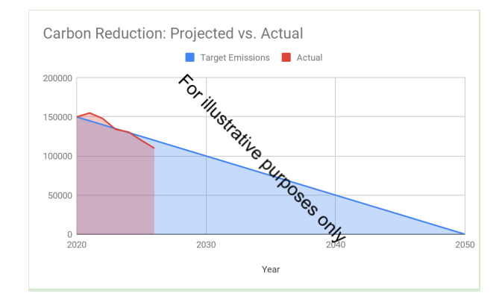
Carbon Reduction Projects
Completed Carbon Reduction Initiatives
The following environmental management measures and projects have been completed or implemented since the 20XX baseline. The carbon emission reduction achieved by these schemes equate to XX tCO2e, a XX%ge reduction against the 20XX baseline.
[Instructions to Suppliers: Briefly provide details of some of your completed carbon reduction projects. This is for information only. This may include environmental management measures such as certification schemes like ISO14001 or PAS 2060, signing up to SBTI or specific measures you have taken such as; the adoption of LED/PIR lighting controls, changes to policy resulting in a reduction in company travel and flights or the electrification of the company fleet.]
In the future we hope to implement further measures such as:
[Instructions to Suppliers: Briefly provide details of some of any likely/proposed future carbon reduction projects. This is for information only.]

Carbon offsetting plans
[Instructions to Suppliers: Briefly provide details of some of any likely/proposed future carbon offsetting projects. This is for information only. Note the total and % offset should decrease for each time period, towards a maximum of 10% offset and an ideal goal of zero offset]

Declaration and Sign Off
This Carbon Reduction Plan has been completed in accordance with PPN 06/21 and associated guidance and reporting standard for Carbon Reduction Plans.
Emissions have been reported and recorded in accordance with the published reporting standard for Carbon Reduction Plans and the GHG Reporting Protocol corporate standard and uses the appropriate Government emission conversion factors for greenhouse gas company reporting .
Scope 1 and Scope 2 emissions have been reported in accordance with SECR requirements, and the required subset of Scope 3 emissions have been reported in accordance with the published reporting standard for Carbon Reduction Plans and the Corporate Value Chain (Scope 3) Standard.
This Carbon Reduction Plan has been reviewed and signed off by the board of directors (or equivalent management body).
Signed on behalf of the Supplier:

………………………………………………………………….
Date: ……………………….……….

https://ghgprotocol.org/corporate-standard
https://www.gov.uk/government/collections/government-conversion-factors-for-company-reporting
https://ghgprotocol.org/standards/scope-3-standard
https://ghgprotocol.org/corporate-standard
https://www.gov.uk/government/collections/government-conversion-factors-for-company-reporting
https://ghgprotocol.org/standards/scope-3-standard

