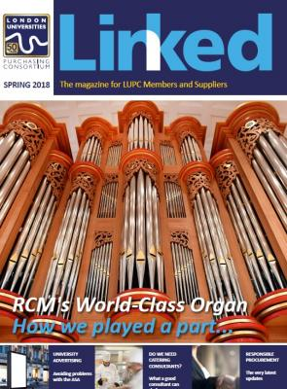
Advertising in LUPC’s Linked magazine

To cover the costs of producing a quarterly edition of LUPC’s Linked magazine, we offer LUPC approved suppliers the opportunity to advertise.

Benefits

- Our circulation includes more than 500 individual buyers at more than 70 member institutions, plus all of LUPC’s suppliers.
- The magazine reaches a section of contract users that do not regularly access the web.
- The magazine is also available to anyone who accesses the LUPC website, including back issues.
- Your support demonstrates to customers your commitment to LUPC agreements.

Advertisement Rates

- £250 +VAT for quarter page
- £500 +VAT for half page
- £1,000 + VAT for full page
- 10% discount available for booking 4 consecutive spaces in advance

Invoices are sent once the issue with the advertisement is published. Payment is due by 30 days past invoice date.

Please note, if you are no longer an approved supplier to LUPC Members at the date of publication, we cannot publish your advert and we will refund your payment.

Guidelines

- Advertisement and editorial submissions are granted strictly on a first come, first serve basis.
- Deadlines must be strictly adhered to.
- Artwork guidelines must be followed.
- Suppliers may not specifically promote goods and services that are outside the scope of your agreement with LUPC – promoting products covered by the agreement and/or a general company advert (making reference to the agreement) is fine.
- All adverts must include:

- Supplier contact details (a website, email etc)
- Reference should be made to the agreement and, where relevant, agreement logo
- The standard term for approved suppliers is ‘LUPC framework supplier’, not ‘Preferred
supplier’ or ‘Number 1 Supplier’.

Artwork specification

- Supply artwork as a high resolution, print ready pdf to l.compton@lupc.ac.uk  - Advert bleed to be 3mm | - Images to be high res and colour, min. 300dpi  - Please ensure fonts are embedded in adverts when the PDF is created
Copy Area :

- Full page 210mm (horizontal) x 297mm (vertical)
- Horizontal Half page 192mm (horizontal) x 144mm (vertical)
- Quarter page 94.5mm (horizontal) x 144mm (vertical)

Contacts and booking

To book your advert, you must sign the authorisation form on page 3 and return this to l.compton@lupc.ac.uk.

For queries about bookings, please contact Laura Compton on 020 7307 2766.

Editorial Submissions

We also welcome articles from suppliers about current issues/updates in your commodity markets, case studies, best practice, sustainability etc. There is no charge for placing these articles, but they must focus on the ‘big issues’, rather than being an overt ‘sell’ for a particular supplier. For more information contact Laura Compton, 020 7307 2766.

2019 Schedule

Winter 2019 (published January)
Artwork deadline: Friday 14th December 2019

Spring 2019 (published April)
Artwork deadline: Friday 29th March 2019

Summer 2019 (published July)
Artwork deadline: Monday 8th July 2019

Autumn 2019 (published October)
Artwork deadline: Friday 11th October 2019

Linked Advertising Authorisation Form

Company Name:

Name:

Email:

Tel:

Purchase Order Number (if applicable):

Invoice Address:

Which issue?

Winter 2018/19 (Jan) Summer 2019 (July)

Spring 2019 (April) Autumn 2019 (October)

Size of advert:

Quarter page

£250 +VAT

Half page

£500 +VAT

Please state if half page advert will be horizontal or vertical in orientation:____________________________

Full page

£1000 + VAT

Signature and date

Please note: This booking form commits you to paying for the agreed advertising after publication. Adverts cancelled 21 days before the advert artwork deadline will be charged 100% of the agreed fee.

Email completed form to: Laura Compton - L.Compton@lupc.ac.uk

