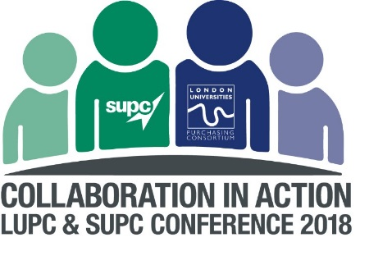
LUPC & SUPC Conference 2018 - Additional Sponsorship & Advertising Opportunities
LUPC and SUPC are able to offer confirmed Exhibitors a number of additional advertising, promotion and sponsorship opportunities at our Conference on Thursday 24th May.
The ‘Further Information’ section at the bottom of these pages should help familiarise you with room and exhibition locations.
Please note, all advertising and promotion at the Conference must reflect your status on the agreement, and not be used to promote off-contract goods and services.

Conference programme
Our 20-page printed Conference programme will be provided to 250+ delegates, with opportunities for paid-for advertising and sponsorship as follows:
- Programme sponsorship – single opportunity
Full programme sponsorship – an inside full page advert (worth £1000 + VAT) plus your logo and sponsor status displayed prominently on the front cover.
£2,250 + VAT

- Programme advertising – multiple opportunities
Exhibitors can book additional advertising for inside the Conference programme, at the following rates.
Full page A4 advert: £1,000 + VAT
Half page advert: £500 + VAT
Screens
There are various large media walls and screens (16:9 ratio) around the venue which exhibitors would be able to advertise on during the course of the day. These screens are available for hire in the following locations:

- Premium registration area – multiple opportunities
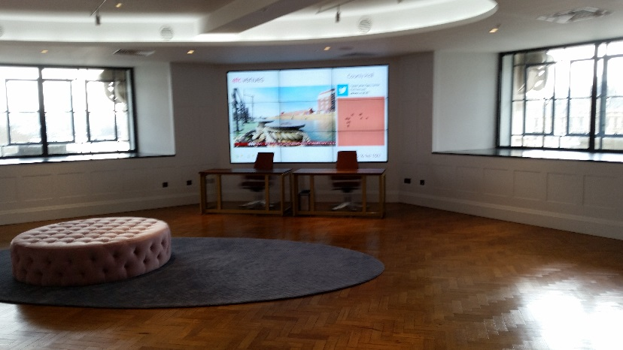
Right next to our registration, where all 250+ delegates will pass into the Conference venue in the morning, this large media wall is situated in the main Exhibition area and static adverts/images can be displayed all day on rotation with the Conference logo.
£500 + VAT per advert

- Westminster Suite/Exhibition area (all day hire) - multiple opportunities
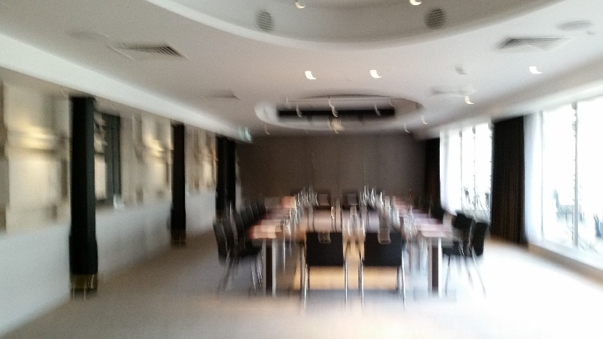
The smaller room of the Exhibition leads on to a balcony, and static adverts/images can be displayed all day on the Westminster Suite’s single drop down screen.
£500 + VAT per advert
Rooms – hire and sponsorship
- County Suite sponsorship (all day) – single opportunity

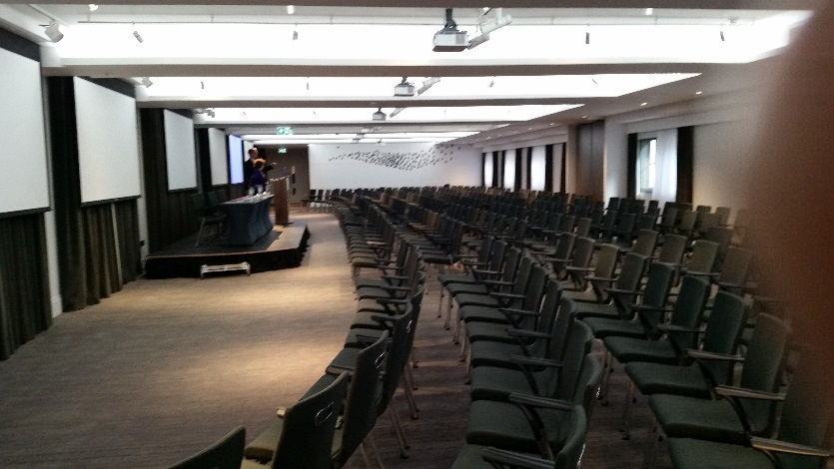

A single exhibitor will be able to sponsor the County Hall Suite, used for the main plenary sessions attracting 250+ delegates, plus larger breakout sessions (50 people +) all day. This sponsorship will include:

- Ability to display a roller banner (provided by exhibitor) near delegate entrance to the County Suite.
- Lectern sponsorship - your logo displayed on lectern alongside Conference logo (provided by LUPC & SUPC)
- Small leaflet distributed on delegate seats at start of the day (provided by exhibitor in advance)
- Screens will be used for presentations during plenary sessions, but adverts and images can be displayed as all delegates enter these sessions (digital image/advert supplied by exhibitor to spec).
£3,000 + VAT

- Lords 1, 2, 3 breakout room sponsorship (all day) – multiple opportunities
Exhibitors will be able to sponsor individual breakout rooms, with the same benefits as listed for County Suite sponsorship. Note, more popular sessions will be allocated the larger Lords rooms.
Lord 1: Capacity 40 theatre.
£750 + VAT
Lord 2: Capacity 60 theatre.
£1,100 + VAT
Lord 3: Capacity theatre 70.
£1,300 + VAT
For a conversation on which workshop topics will be in which rooms (currently tbc) please contact Laura Compton, t: 020 7307 2766How to book
For further information and to book, please contact Laura Compton, LUPC Assistant Director (Membership), t: 020 7307 2766. Sponsorship will be allocated on a first come, first served basis. Your sponsorship will not be secure until payment is received in advance of the event.
Further information
Exhibition floor plan
Venue floor plan
Note: County Suite (plenary area and largest breakout room); Thames Suite (exhibition area); Lords 1-3 (breakout rooms); Speakers Event Space and Coade Room (drinks reception).
Delegates enter and leave via the Reception (left of floorplan), and morning registration takes place in the corner space to the right of the floorplan (top right of Thames Suite).

